###### 1 OVERVIEW

1.1 **Business Goals**

The business goal of the system is to sell products online. The products detail will be uploaded to the system by vendors. It also allows vendors to modify their products information. Customers can search for a product and order it by paying using VISA/MASTER card.

1.2 **Business Process Overview**

The use case diagram below shows the main overview of the business processes and interaction between stakeholders.

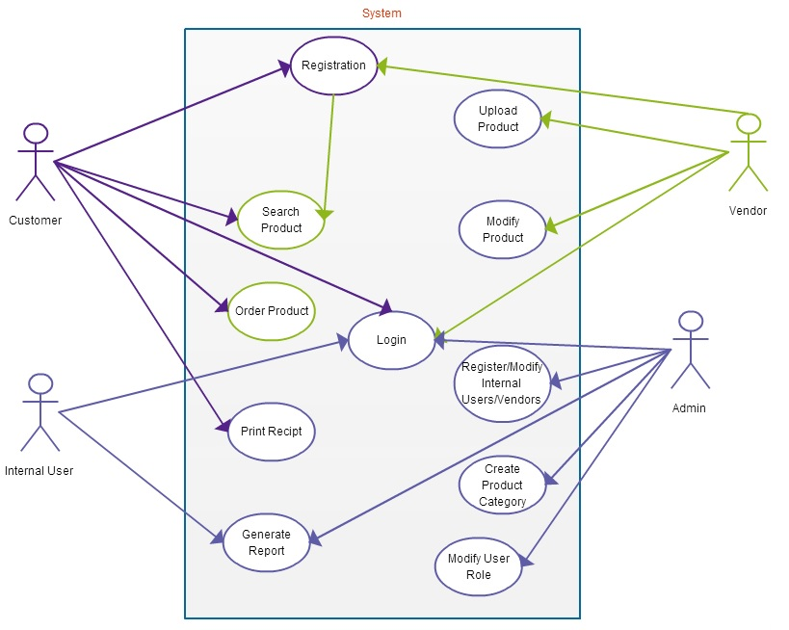

**1.3** **Objectives of System**

The main objectives of the system are:

* To order products online
* Add/modify products information by vendors
* Send order confirmation(receipt) and invoice for customer
* Generate reports for administrators

**2 BUSINESS PROCESS**

2.1 **Process map**

#### Order Management Process

|  |  |
| --- | --- |
| Customer | Submit Order  Select Product  Search Product |
| Payment Gateway | Y  Payment  Validate Card |
| MyFinance.com |  |
| Online Shopping System | Generate Receipt |

2.2 **Business Functions**

The main business functions of the system.

* Customer registration
* Vendor registration (approved by admin)
* Upload products info. (by vendors)
* Search a product
* Order product
* Payment using VISA/MASTER card
* Generate reports for admin, order confirmation(receipt) and invoice for customer

3 BUSINESS FUNCTIONS

3.1 **Functional Requirements**

Business function: Order Process of Registered Customer

Description of the function

This process is one of the core processes of the system that enables customer to select product, pay using credit or debit card and finally print the receipt.

Roles

Customer, PaymentGateway, myFinance.com

Input

List input used and reference or attach the layout

Output

List output that are produced and reference or attach the layout

Flow of Events

The following table shows the sequential flow of events :

a) Event Table

|  |  |  |
| --- | --- | --- |
| **Sequence No.** | Role’s Action | System Response |
| 1 | USER- Log in to the system | Authenticate the user and redirect to client’s home page (If the user is authenticated). If the user is not authenticated, display error message. |
| 2 | USER- Search for product | Search a product based on search text input of the customer and display all the products that match the search text. |
| 3 | USER- Add to cart | Add selected products to customer’s shopping cart |
| 4 | myFinance- Pay using VISA/MASTER card | Verify the customer’s card details and respond Y or N to show the status. |
| 5 | USER- Print receipt | Generate receipt as and sent to the customer by email. |
| 6 | USER- Log out from myCompany.com | Sign off the user from the system and deactivate the users session. |

1. Sequence Diagram

The sequence diagram shown below is for registered customer. The sequence diagram show the sequence events described above. Customer search for the product, add one or more products to the cart then finally pay for the products. An order confirmation or receipt will be sent to the customer.

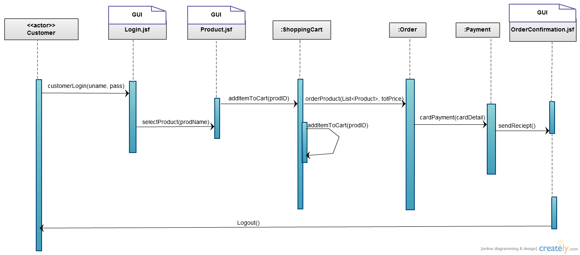

**4 OTHER REQUIREMENTS**

1. SECURITY REQUIREMENTS

- The system is role based, so all users should be assigned to one of the five roles (Customer, InternalUser, Admin, Vendor, Guest) at the time of registration

* **Payment transaction shall be secured using SSL**

1. EXTERNAL INTERFACES

* NO external interface is included in the scope detail.

1. ARCHIVAL REQUIREMENTS

- Periodic backup will be taken to keep customers history and transactions.

1. CONTINGENCY REQUIREMENTS (An emergency backup?)

For critical business functions, specify:

- Tolerable downtime

- Types of records, frequency (daily, weekly etc.) and retention period of the backup

- Fallback mechanism to continue operations during downtime (eg. switch to another alternative computerised system, rely on localised processing, resort to manual procedures, etc.)

# 5 SYSTEM/OPERATING ENVIRONMENT

Define the system environment and network infrastructure. Illustrate with diagram (if needed) to describe user location with respect to the host system/server and input/output equipment and document the following :

a) Communications Overview

Specify the method of communication that will support the system (e.g. network layout and features)

b) Hardware Requirements/Configuration

Specify the hardware requirements/configuration, which include number of workstations, peripherals and customer location for installation of hardware.

c) System Software

List the system software required (eg. operating system, utilities) and indicate version/release number and other pertinent details.

6 ASSUMPTIONS AND LIMITATIONS

**Assumptions**

* User credit amount will be inserted to the database automatically at the time of user registration.

*  Report, invoice and receipt printout format will be in “PDF”

*  There are 5 types of user roles namely “Admin”, “InternalUser”, “Vendor”, “Customer” and “Guest”

* Vendors will be able to insert their products into the system.

* Sold item revenue will be shared between the vendor and mycompany.com in 70:30 ratio.

* The admin will create product categories and internal users

7 USER INTERFACE DESIGN CONCEPT

Document the user interface design concept/standard for the system. For Web Applications, document the design theme for the web page and describe the design concept for the following :

* Background
* Screen layout (provide sample, if necessary)
* User interactions
* Text font / style
* Icons
* Buttons
* Frames
* Header / Footer / Terms and Conditions

###### 8 SCENARIO FLOW / USER INTERFACE DEMO

Business process: Order a product (for registered customer)

Customer

Guest

Is Registered User

Y

Y

N

Has Card Information

N

Print Receipt

Confirmation

Shipping Details

Payment Detials

Submit Order

Select Product(s)

Search Product

Login